**QGIS Boundary Extraction SOP**

Need to install the following Plugins and make sure they are visible: Advanced Digitizing Toolbar; Attribute Toolbar; Mange Layers Toolbar; Rectangles, ovals digitizing tools

* Install by going to **Plugins** in top toolbar
* Make sure they are visible by going to **View** > **Toolbars** and making sure desired toolbars are selected

1. Add raster layer by going to **Layer** > **Add Layer** > **Add Raster Layer**
   1. Raster layer used will be the orthomosaics
   2. Folder: Photoscan Projects/2019/Waseca_Exp1 (or Exp 2)/ Agisoft Projects/Ortho/mmddyyyy_ortho.tif
2. Create Grid vector file according to plot/row spacings
   1. Go to the Processing Toolbox toolbar > QGIS geoalgorithms > Vector creation tools > Create Grid. If you cannot see the Processing toolbox, add it the window by going to View in top menu > Panels > Toolbox
      1. Select Grid Type: Rectangle (polygon)
      2. Select Grid Extent by clicking on the three dots on the right and selecting “Select Extent on Canvas” then highlighting region where you want the grid to be drawn
         1. Note that you should begin the grid half way to the alley on the left of the topmost plot desired and halfway to the row above.
      3. Horizontal spacing: 0.000092
      4. Vertical Spacing: 0.000007
      5. Grid CRS: select Coordinate Reference System WGS 84; Authority ID ESPG: 4326

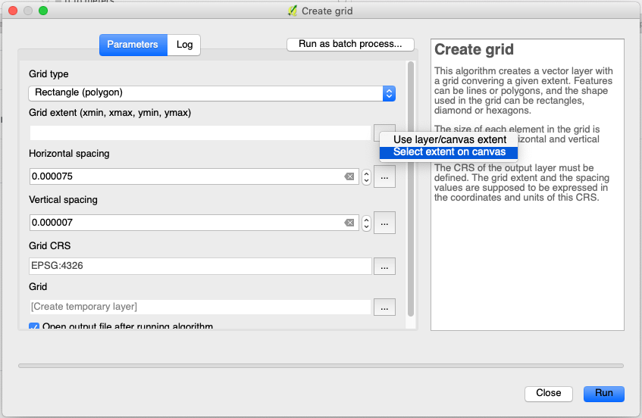

* 1. Click “Run”

1. Modify plot vector layer so that polygons fall directly above plots
   1. Right click on polygon layer “Grid” on Layers Panel and go to “Properties”
      1. Change transparency to ~70% so you can see plot below polygons and change color to something clearly visible like pink.
   2. Click *Toggle Editing*  to edit Grid polygon layer.
   3. Click *Select Features*  and highlight polygons you want to move.
   4. Click Move Features  to move selected polygons. Be very careful not to change the order of the polygons.
2. Once done, save layer by right-clicking on the layer name in the *Layers Panel* > Save as Layer Definition File
3. A plot boundary file for each experiment should be saved under:

LAB-Springer/Sara_T/Photoscan Projects/2019/Waseca_Exp1 (or Exp 2)/QGIS Layers/Date (mmddyyyy)/filename

File name: Plots_Exp.shp

*Exp will be WasecaExp1 or WasecaExp2*

1. Create Boundary layer for each experiment separately.
   1. GC1
   2. GC2
   3. NC
   4. WiDiv
2. Save each orthomosaic file as a geotiff image by selecting the orthomosaic raster layer in the *Layers Panel* and then going to the toolbar at the top of the screen to **Layer** > **Save as** and saving the raster layer in a GTiff format. Leave the remaining parameter to default settings. (see screenshot below)
   1. Make sure saved layer is in the right format before saving by selecting the raster layer in the *Layers Panel* and right clicking on it and selecting *Properties*, then going to the *Transparency* tab and unselecting “No Data Value” if it is defined. A new layer will show up after saving, go to properties for that new layer and ensure *No data value: not defined* shows up. (see screenshot below)

Save under LAB-Springer/Sara_T/Photoscan Projects/2019/Waseca_Exp1 (or Exp 2)/QGIS Layers/Date (mmddyyyy)/filename

File name: mmddyyyy_geotiff.tif

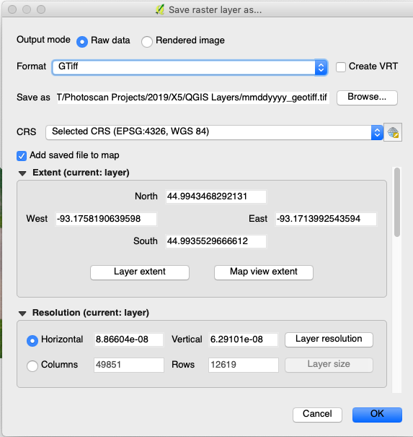

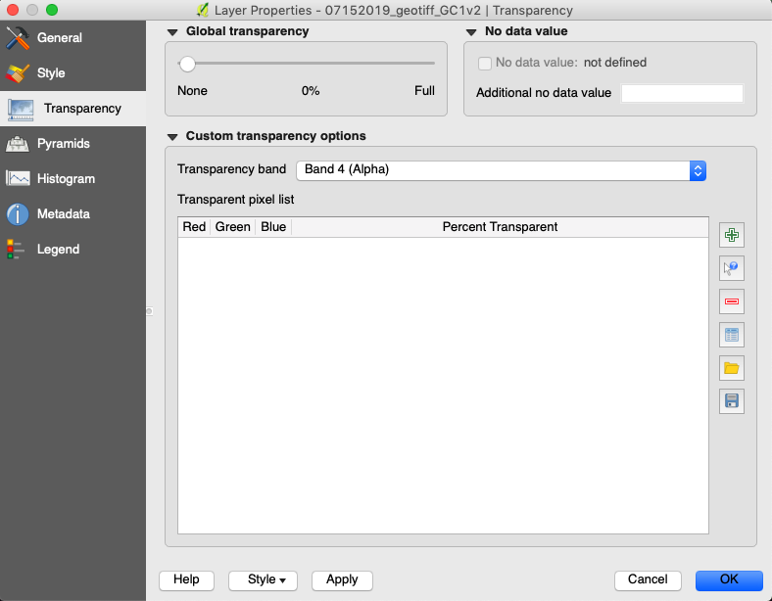

1. Save each DEM file as a geotiff image by following the same procedure above but with the DEM raster layer rather than orthomosaic

Save under LAB-Springer/Sara_T/Photoscan Projects/2019/Waseca_Exp1 (or Exp 2)/QGIS Layers/Date (mmddyyyy)/filename

* 1. File name: mmddyyyy_geotiffDEM.tif

1. Save snapshot of each geotiff image experiment by selecting the mmddyyyy_geotiff.tiff raster layer in the *Layers Panel* and going in the top toolbar to Raster > Extraction > Clipper. Select the input layer (mmddyyyy_geotiff.tiff ), select the output file directory and name as specified below, select “Extent”, and select the desired area in the geotiff raster, then click “OK”.

*Note: try not to not capture grass area/ GCPs/panels/etc. only plant plots*

Save under LAB-Springer/Sara_T/Photoscan Projects/2019/Waseca_Exp1 (or Exp 2)/QGIS Layers/Date (mmddyyyy)/filename

File name: mmddyyyy_geotiff_Exp.tif

*Exp will be GC1, GC2, NC, WiDiv*

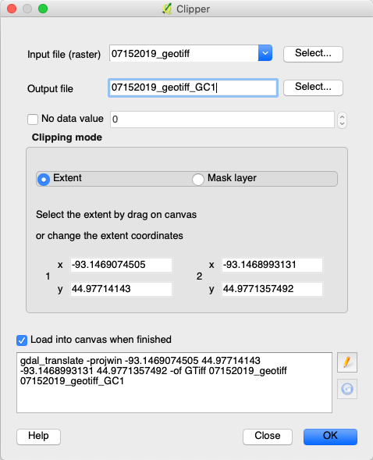

JC 11/09/2023

Waseca Production Field Orthomosaic Clipping

1. Load mmddyyyy_geotiff: **Layer** > **Add Layer** > **Add Raster Layer**
2. Load .shp but have other files in same folder: **Layer** > **Add Layer** > **Add Raster Layer**
3. Raster extraction on mmddyyy_geotiff: **Raster > Extraction > Clip Raster by Extent**

* Input Layer: mmddyyyy_geotiff
* Clipping Extent: Calculate from layer > .shp
* Clipped Extent: Save to a file > mmddyyyy_geotiff_QGISclipped